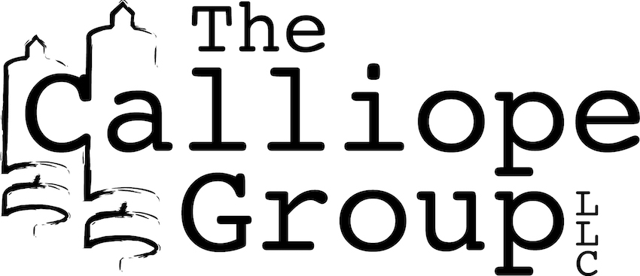

Media Contact: Shawn Crawford, sdc@calliopecrashes.com
The Calliope Group: 3618 E. 48th Street, Tulsa, Oklahoma 74135, thecalliopegroup.com
Twitter, Facebook: @TCGBooks

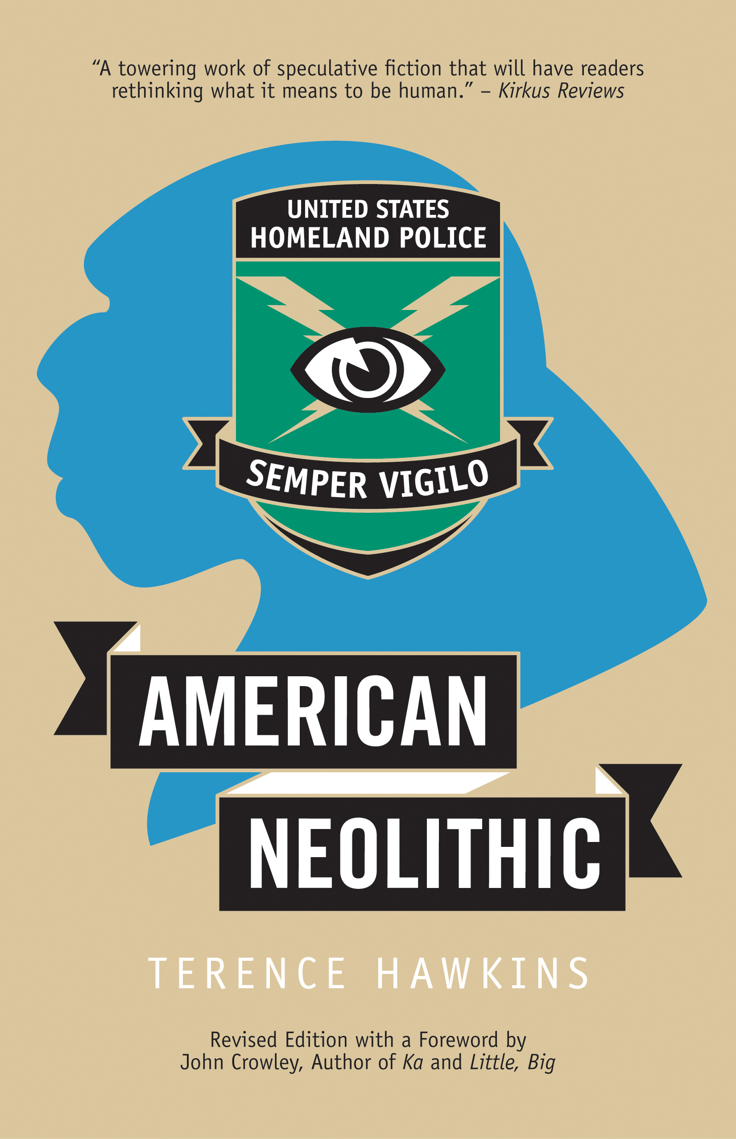
The Calliope Group announces the release of American Neolithic, Revised Edition, a novel by Terence Hawkins. American Neolithic (Trade Paperback, ISBN: 978-1-7336474-2-7, $17, eBook ISBN: 978-1-7336474-3-4, $17, 178 pages) will be available everywhere November 4, 2019 and can be pre-ordered now at https://thecalliopegroup.com/book/american-neolithic/.
SYNOPSIS
America is Police State Lite. The Bill of Rights has been swallowed by the Patriot
Amendments. Science bends the knee to state-sponsored Creationism. The Supreme
Court is powerless before the Patriot Tribunal and the Homeland Police–their motto,
“Always Watching.” Enter Blingbling. The only literate member of the sole surviving band of Neanderthals who live in hiding on Manhattan’s Lower East Side. Earning money for the Nest, he is implicated in a hip-hop murder; shadowy benefactors retain a lawyer, the hard-boiled Raleigh. When a routine DNA swab reveals that he fits no known human genotype, the Homeland Police take notice. If Blingbling’s true ancestry is disclosed, his people are in jeopardy. Raleigh finds himself caught in a professional and personal trap that can destroy his client, his career, and much more. Political satire, courtroom thriller, and speculative fiction, American Neolithic is also a story of loyalty, betrayal, and redemption. Terence Hawkins has written a smart, dark, funny book that is ultimately deeply moving.

“Hawkins’s gentle treatment of these displaced persons, their care for one another, the immigrant troubles so universal we recognize them immediately and then catch ourselves—this family is unrepresented in family scrapbooks and photos. It’s unsettling, as it is intended to be, this American tale that isn’t like anybody else’s even while it’s the same tale as always. For what is mostly a comic—or at least humorous — novel, American Neolithic is oddly touching in many places.”-- John Crowley, author of Ka and Little, Big, from the Foreword

AUTHOR BIO
Terence Hawkins was born in Uniontown, PA. His grandfather and several uncles worked the coal mines. He graduated from Yale and the University of Wisconsin Law School. In 2012 he became the founding Director of the Yale Writers’ Conference, which he ran through 2015. He now heads The Company of Writers. Hawkins’s first novel, The Rage of Achilles, an account of the Iliad informed by the theory of the bicameral mind, appeared in 2009. Turing’s Graveyard, a collection of his short stories and humor, will appear in 2020 from Running Wild Press.

If you’d like to reach Terence Hawkins for an interview, please let us know.

The Calliope Group in an independent publisher in Tulsa, Oklahoma. Titles can be ordered directly from The Calliope Group at thecalliopegroup.com, at independent bookstores, and online through all major channels including Amazon and Barnes & Noble.

