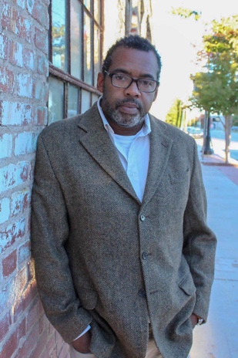
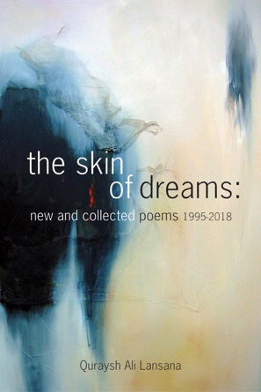
FOR IMMEDIATE RELEASE
Contact: Shawn Crawford
sdc@calliopecrashes.com
785.826.7681

Poems that Cry, Sing, Scream, and See:
Quraysh Ali Lansana Releases First New and Collected Works

“Quraysh Ali Lansana has woven a roadmap of poems and prophecy from Tulsa to Chicago,
slowly breaking open the voices of history with each step. Here is a friendship journey, a
father/son Southside Chi meditation for the 21st century blues. Follow the path on these
pages to enter your own skin.” Tyehimba Jess, Pulitzer Prize winner, Olio

Tulsa, Oklahoma—Poet, historian, and educator Quraysh Ali Lansana has seen his art take him from Oklahoma to Chicago and back. He considers the journey and charts the path forward in his new and collected poems, the skin of dreams. The book offers a remarkable meditation on family, race, history, and rural and urban realities.

“We find our griot singing both his history and our own in the skin of dreams, and what a soulful chord he strikes – and has been striking! – throughout the years...[The poems] chronicle the dedication Lansana has put into keeping history current, chronicling the human experience through the African American presence. In this collection, he ‘captures present moments fleeting seconds’ understanding ‘we will never be here again,’ but we’re grateful
for his song, which keeps harkening back while pushing us forward.” A. Van Jordan, Rise and Quantum Lyrics

The author of eight books of poetry, Lansana studied with the acclaimed poet Gwendolyn Brooks and found influences in the Black Arts Movement. Works include Walmart Republic with Christopher Stewart (2014), mystic turf (2012), bloodsoil (sooner red) (2009), Southside Rain (2000), and cockroach children: corner poems and street psalms (1995).

“Poetry as more than a decorative furnishing in American literature, Lansana extends and reifies a long tradition of communal voicings, political activism, and social engagement but not at the expense of his own self-hood.” Major Jackson, Roll Deep and Hoops

As an educator, Lansana taught as a faculty member of the Writing Program of the School of the Art Institute of Chicago and the Drama Division of The Juilliard School. As Director of the Gwendolyn Brooks Center for Black Literature and Creative Writing at Chicago State University from 2002-2011, he was also Associate Professor of English/Creative Writing there until 2014. Written with Georgia A. Popoff, Our Difficult Sunlight: A Guide to Poetry, Literacy & Social Justice in Classroom & Community was a 2012 NAACP Image Award nominee.

“Lansana is a poet of such power, grace, and witness: how glorious it is to have the many threads of his work drawn into this stark and heartbreaking collection. In these homehaunted verses he mourns our losses, celebrates family, friends, fatherhood, tells us what the country is, has been, can be.” Rilla Askew, Most American and Kind of Kin

Continuing the legacy of Gwendolyn Brooks and championing other voices, Lansana’s recent work also includes The Whiskey of Our Discontent: Gwendolyn Brooks as Conscience & Change Agent, with Georgia A. Popoff (2017) and The BreakBeat Poets: New American Poetry in the Age of Hip Hop, with Kevin Coval and Nate Marshall (2015). His work will also appear in Best American Poetry 2019.

Recently named a Tulsa Artist Fellow, Lansana will become the executive producer and creative director of a radio program, “Focus: Black Oklahoma.” The show will originate from KWGS at the University of Tulsa and air on National Public Radio affiliates in Oklahoma. “Think of ‘All Things Considered’ for black Oklahomans,” said Lansana.

the skin of dreams will be released April 27th under the Purple Basement Poetics imprint of The Calliope Group. The book can be ordered from the publisher at thecalliopegroup.com and found online and in bookstores.

30

